CHAPTER 4: THE ENHANCED ENTITY-RELATIONSHIP (EER) MODEL

Answers to Selected Exercises

4.16 – No solution provided.

4.17 - Consider the BANK ER schema of Figure 7.21, and suppose that it is necessary to keep track of different types of ACCOUNTS (SAVINGS_ACCTS, CHECKING_ACCTS,
...) and LOANS (CAR_LOANS, HOME_LOANS, ...). Suppose that it is also desirable to keep track of each account's TRANSACTIONs (deposits, withdrawals, checks, ...) and each loan's PAYMENTs; both of these include the amount, date, time, ... Modify the BANK schema, using ER and EER concepts of specialization and generalization. State any assumptions you make about the additional requirements.

Answer:

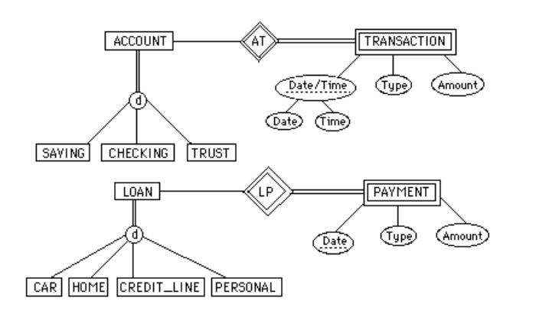

4.18 - No solution provided.

4.19 - Identify all the important concepts represented in the library database case study described here. In particular, identify the abstraction of classification (entity types and relationship types), aggregation, identification, and specialization/generalization. Specify (min, max) cardinality constraints whenever possible. List details that will affect the eventual design but which have no bearing on the conceptual design. List the semantic separately. Draw an EER diagram of the library database.

Answer:

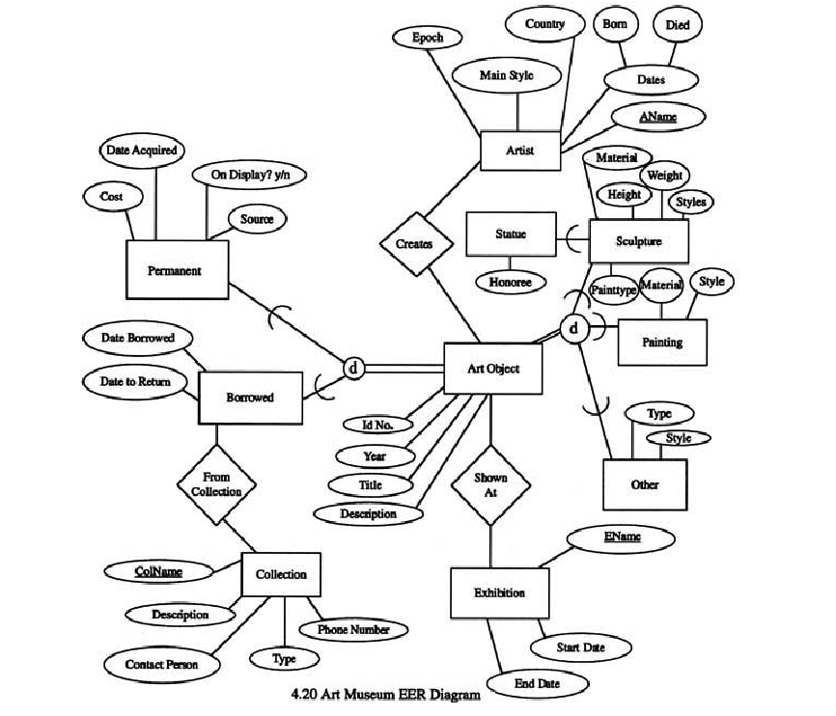

4.20 - No solution provided.

4.21 - Figure 8.12 shows an example of an EER diagram for a small private airport database that is used to keep track of airplanes, their owners, airport employees, and pilots. From the requirements for this database, the following information was collected: Each airplane has a registration number [Reg#], is of a particular plane type [of_type], and is stored in a particular hangar [stored_in]. Each plane_type has a model number [Model], a capacity [Capacity], and a weight [Weight]. Each hangar has a number [Number], a capacity [Capacity], and a location [Location]. The database also keeps track of the owners of each plane [owns] and the employees who have maintained the plane [maintain]. Each relationship instance in owns relates an airplane to an owner and includes the purchase date [Pdate]. Each relationship instance in maintain relates to an employee to a service record [service]. Each plane undergoes service many times; hence, it is related by [plane_service] o a number of service records. A service record includes as attributes the date of maintenance [Date], the number of hours spent on the work [Hours], and the type of work done [Workcode]. We use a weak entity type [service] to represent airplane service, because the airplane registration number is used to identify a service record. An owner is either a person or a corporation. Hence, we use a union type (category) [owner] that is a subset of the union of corporation [Corporation] and person [Person] entity types. Both pilots {Pilot] and employees [Employee] are subclasses of person. Each pilot has specific attributes license number [Lic_Num] and restrictions [Restr]; each employee has specific attributes salary [Salary] and shift {Shift]. All person entities in the database have data kept on their social security number [Ssn], name [Name], address [Address], and telephone number [Phone]. For corporation entities, the data kept includes name [Name], address [Address], and telephone number [Phone]. The database also keeps track of the types of planes each pilot is authorized to fly [Flies] and the types of planes each employee can do maintenance work on [Works_on]. Show how the small airport EER schema of Figure 8.12 may be represented in UML notation. (Note: We have not discussed how to represent categories (union types) in UML, so you do not have to map the categories in this and the following question.)

Answer:

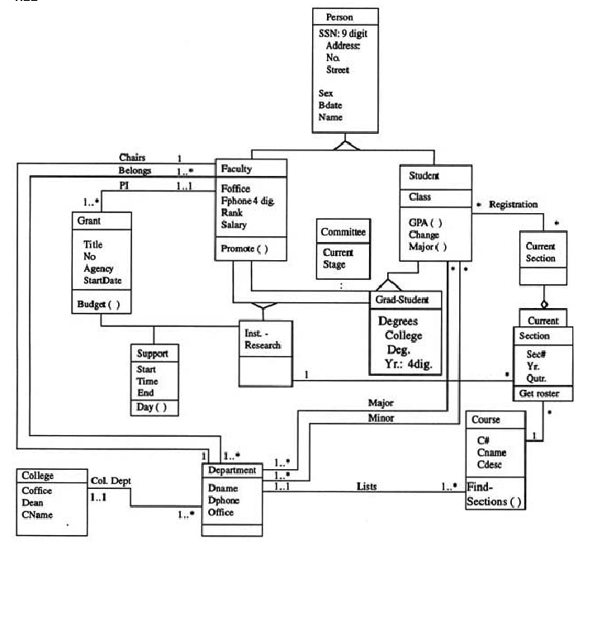

4.22 – 4.23 – No solutions provided.

4.24 - Draw a UML diagram for storing a played game of chess in a database. You may look at http://www.chessgames.com for an application similar to what you are designing. State clearly any assumptions you make in your UML diagram. A sample of assumptions you can make about the scope is a follows:
1. The game of chess is played between two players.

2. The game is played on an 8x8 board like the one shown below:

3. The players are assigned a color of black or white at the start of the game.

4. Each player starts with the following pieces (traditionally called chessmen):
a. 1 king
b. 1 queen
c. 2 rooks
d. 2 bishops
e. 2 knights
f. 8 pawns

5. Every piece has its own initial position.

6. Every piece has its own set of legal moves based on the state of the game. You do not need to worry about which moves are legal and which are not other than the following issues:

a. A piece may move to an empty square or capture an opposing piece.
b. If a piece is captured, it is removed from the board.
c. If a pawn moves to the last row, it is “promoted” but converting it into another piece (a queen, a rook, a bishop, or a knight).

Note: Some of these functions may be spread over multiple classes.

4.25 – No solution provided.

4.26 - Which of the following EER diagram(s) is/are incorrect and why? State clearly any assumptions you make.
E1

R
o
a)
N
E
1
E3

A
E2
B

1
E1
R
d
b)
E

A
1
E2

o
c)

R
E1
E3
N
M
A
C

Answer:
Only (c) is incorrect.

4.27 - Consider the following EER diagram that describes computer systems at a company. Provide your own attributes and key for each entity type. Supply max cardinality constraints justifying your choice. Write a complete narrative description of what this EER diagram represents.

Computer
Software
Installed
InstalledOS

d
U
U
U

Laptop
Desktop
Operating
System
SoldWith
Supports

Options
Options

Component
Accessory

d
d
U
U
U
U

Keyboard
Mouse
Memory
Video card
U
U

Monitor
Sound card

